Work plan

Deadlines
- 2018-02-26 Choose a project proposal and send your choice via email to epsatisep@gmail.com
- 2018-03-05 Define the Tasks (what must be done - every member should preferably participate in every task), subtask allocation (who does what) and Gantt chart (when) of the project and insert them on the wiki (planning)
- 2018-03-12 Upload the “black box” System Diagrams & Structural Drafts to the wiki
- 2018-03-23 Upload the detailed System Schematics & Structural Drawings to the wiki and do the cardboard scale model of the structure
- 2018-04-04 Upload the List of Materials (what & quantity) to the wiki
- 2018-04-14 Upload the Interim Report and Presentation to the wiki. The report must contain the Introduction, including the tasks, team members allocation and Gantt chart, State of the Art, Marketing Plan, Project Management, Eco-eficiency Measures for Sustainability, Ethical and Deontological Concerns, Proposed Solution and Bibliography chapters
- 2018-04-19 Interim Presentation, Discussion and Peer, Teacher and Supervisor Feedbacks
- 2018-04-23 Complete the List of Materials (local providers & price, including VAT and transportation) to the wiki
- 2018-05-02 Upload refined Interim Report (based on Teacher & Supervisor Feedbacks)
- 2018-06-04 Upload the results of the Functional Tests to the wiki
- 2018-06-15 Upload the Final Report
- 2018-06-18 Upload the Presentation, Video, Paper, Poster and Manual
- 2018-06-21 Final Presentation, Individual Discussion and Assessment
- 2018-06-28:
  - Update the wiki with all correction suggestions
  - Hand in to the EPS coordinator:
    - a CD with the corrected deliverables (source + PDF) together with all code and drawings produced
    - a printed copy of the corrected report and poster
- 2018-06-28:
  - Hand in the prototype and user manual to the client
  - Receive the EPS@ISEP certificate
  - Bring typical food from your country

Tasks
Task | Responsible | Involved
Research | Audrey, Szymon, Mile and Anastasia | Anastasia, Andres, Audrey, Mile, Rodrigo and Szymon
Technical Research | Szymon and Mile | Andres, Mile, Rodrigo and Szymon
Marketing Research | Audrey | Audrey and Mile
Design Research | Audrey | Andres, Audrey, Rodrigo and Szymon
Ethical Research | Anastasia | Anastasia
Sustainability Research | Anastasia | Anastasia
Task identification & Problem Definition | Mile and Audrey | Andres, Audrey , Mile, Rodrigo and Szymon
Roles and Division | Mile and Szymon | Anastasia, Andres, Audrey, Mile, Rodrigo and Szymon
Gantt | Mile | Audrey and Mile
Schematics | Anastasia, Andres, Rodrigo and Szymon | Anastasia, Andres, Audrey, Mile, Rodrigo and Szymon
Drafts | Rodrigo and Szymon | Anastasia, Andres, Audrey, Mile, Rodrigo and Szymon
3D Drafts | Rodrigo | Anastasia, Andres, Audrey, Mile, Rodrigo and Szymon
Draft ethics | Anastasia | Anastasia
Materials | Audrey | Anastasia, Andres, Audrey, Mile, Rodrigo and Szymon
List | Audrey | Anastasia, Andres, Audrey, Mile, Rodrigo and Szymon
Providers | Audrey | Anastasia, Andres, Audrey, Mile, Rodrigo and Szymon
Assembly | Andres, Mile, Rodrigo and Szymon | Anastasia, Andres, Audrey, Mile, Rodrigo and Szymon
System Design | Andres, Mile, Rodrigo and Szymon | Anastasia, Andres, Audrey, Mile, Rodrigo and Szymon
Building the Mechanics | Rodrigo | Rodrigo
Building the Electronics | Andres and Szymon | Andres and Szymon
Programming the Electronics | Mile and Szymon | Andres, Mile and Szymon
Programming the Application | Mile and Szymon | Mile and Szymon
Testing | Andres, Mile, Rodrigo and Szymon | Anastasia, Andres, Audrey, Mile, Rodrigo and Szymon
Communication | Anastasia, Audrey and Mile | Anastasia, Andres, Audrey, Mile, Rodrigo and Szymon
Flyer | Anastasia and Audrey | Anastasia and Audrey
Wiki | Mile | Mile
Video | Mile | Mile
Report | Audrey | Anastasia, Andres, Audrey, Mile, Rodrigo and Szymon
Manual | Audrey | Anastasia, Andres, Audrey, Mile, Rodrigo and Szymon
PPT | Audrey | Audrey and Szymon
Interim Presentation | Anastasia, Audrey and Szymon | Anastasia, Andres, Audrey, Mile, Rodrigo and Szymon
Content | Anastasia, Audrey and Szymon | Anastasia, Andres, Audrey, Mile, Rodrigo and Szymon
Visuals | Audrey and Szymon | Audrey and Szymon
Execution | Anastasia and Szymon | Anastasia and Szymon
Refined Interim Presentation | Anastasia, Audrey and Szymon | Anastasia, Andres, Audrey, Mile, Rodrigo and Szymon
Content | Anastasia, Audrey and Szymon | Anastasia, Andres, Audrey, Mile, Rodrigo and Szymon
Visuals | Audrey and Szymon | Audrey and Szymon
Execution | Anastasia and Szymon | Anastasia and Szymon
Final Report | Anastasia, Audrey and Szymon | Anastasia, Andres, Audrey, Mile, Rodrigo and Szymon
Content | Anastasia, Audrey and Szymon | Anastasia, Andres, Audrey, Mile, Rodrigo and Szymon
Visuals | Audrey and Szymon | Audrey and Szymon
Execution | Anastasia and Szymon | Anastasia and Szymon
Wiki Presentation | Mile | Mile
Video to Wiki | Mile | Mile
Poster to Wiki | Mile | Mile
Paper to Wiki | Mile | Mile
Manual to Wiki | Mile | Mile
Final Presentation | Anastasia, Andres, Audrey, Mile, Rodrigo and Szymon | Anastasia, Andres, Audrey, Mile, Rodrigo and Szymon

Gantt Chart
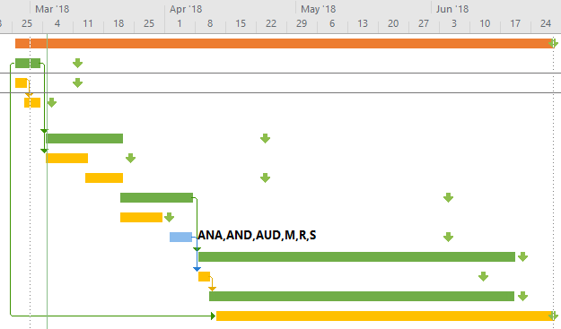
vertical_farming_gantt.zip

